**SYSTEM DESIGN DOCUMENT Two**

Caela Goins, Edwin Catalan, Quadre Jackson

## **1.1 Use case Realizations & Method/Operation Specification**

Usecase ID-1

Password class should handle the login method because it needs the username attribute to select a user.

Password

username

passWd

login()

Use Case Collaboration:

avatar

password

category

user

Use Case Responsibilities:

Password class can get appropriate user object.

User object can access category and avatar objects.

The avatar object holds image options.

The category object holds category list and accesses the question object.

The question object holds a question bank and answer choices.

Method Specification:

userViewPlayerProfile() { *Display user profile attributes*

userName; *username displayed on screen*

availableCategory(); *allows display and selection of player categories*

availableAvatar(); *allows display and selection of player avatars*

}

Use Case ID-2

Question class should handle the response method because the next question depends on the response gathered from the user.

Question

questionBank;

response();

Use Case Collaboration:

category

question

user

Use Case Responsibilities:

User class can access appropriate category object.

The category object holds a category list and accesses the question class.

The question class will have a question bank and answer choices.

Method Specification:

getUserResponse() { *Display questions from bank*

userName; *keep track of user for database*

questionBank(); *allows display and selection of player categories*

response(); *get yes, no, or both responses from user*

}

**1.2 Interaction Diagrams**

**1.2.1 User Interaction: Login and Options**

Twenty Questions

Hello Player, please login

Twenty Questions

Hello [user],

[user]

username

password

Choose

A Category

View

Player Profile

submit

[user]

Twenty Questions

Hello [user],

Best Score

Your Avatars

Twenty Questions

Choose a Category

leaderboard

Choose a category

🡪

**1.2.1 User Interaction: Questions and Response**

Twenty Questions

[Category]

Question #:

Twenty Questions

Hmm…we think it is:

[selection]

Both

No

Yes

No

Yes

Twenty Questions

You beat us!

What was you guess for [category]?

Twenty Questions

Hello [user],

View

Player Profile

Choose

A Category

**1.3 ER Diagram**

|  |
| --- |
| User |
| id |
| username |
| password |

|  |
| --- |
| UserInfo |
| id |
| username |
| password |
| User score |
| Player Profile |

|  |
| --- |
| Play |
| id |
| Choice 1 |
| Choice 2 |
| Choice 3 |

|  |
| --- |
| Game Category |
| id |
| animals |

|  |
| --- |
| UserScore |
| id |
| Correct guess |
| Incorrect guess |

|  |
| --- |
| Animal Type |
| id |
| Mammal |
| Reptile |
| Amphibian |
| Fish |
| Birds |

**1.4 Database Design**

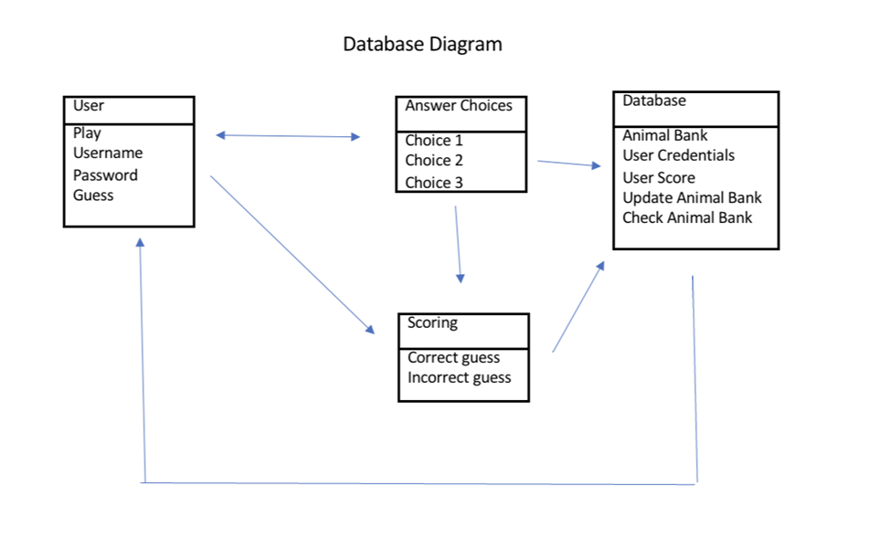

**1.5 Test Cases (Unit Test Cases (BB & WB) + Integration Test Cases)**

|  |  |  |  |  |
| --- | --- | --- | --- | --- |
| Test Case # | Test Description | Test Data | Expected Result | Status |
| 1 | Check User login with correct values. | Known:  Username  Password | Successful login and go to the next page. | Pass/Fail |
| 2 | Check User login with incorrect values. | Unknown:  Username  Password | Unsuccessful login, prompt to make new account. | Pass/Fail |
| 3 | Proper selection of player profile | Known:  Player username and relevant data | Successful transfer to player profile page | Pass/Fail |
| 4 | Proper selection of game category | Known:  Player username and relevant data | Successful transfer to game page | Pass/Fail |
| 5 | Check user input | Known:  Player username and relevant data | Successful capture of user inputs | Pass/Fail |
| 6 | Check database update | Known:  Proper user input | Successful addition to database category | Pass/Fail |